12 - Elvis Costello – What's So Funny
Original key: G Us: same SOLO ALL WURLI
Silent runthough Solo and Grease (next page)
INTRO: snare, 4x main riff
(riff precedes each verse)

VERSE:
G | C | G | C | em | A | D | C | [2x]  [1x]last
G | D/F# | G/F | C (Chugging rhythm)
G/D | D | em | A | G/D | D | em | D

2 verses, then 4x riff
Guitar solo: 1st half of verse (8 bars)
Greg Solo (16 bars)
Last Verse: 2x becomes 1x
Refrain has 4 extra bars with hold
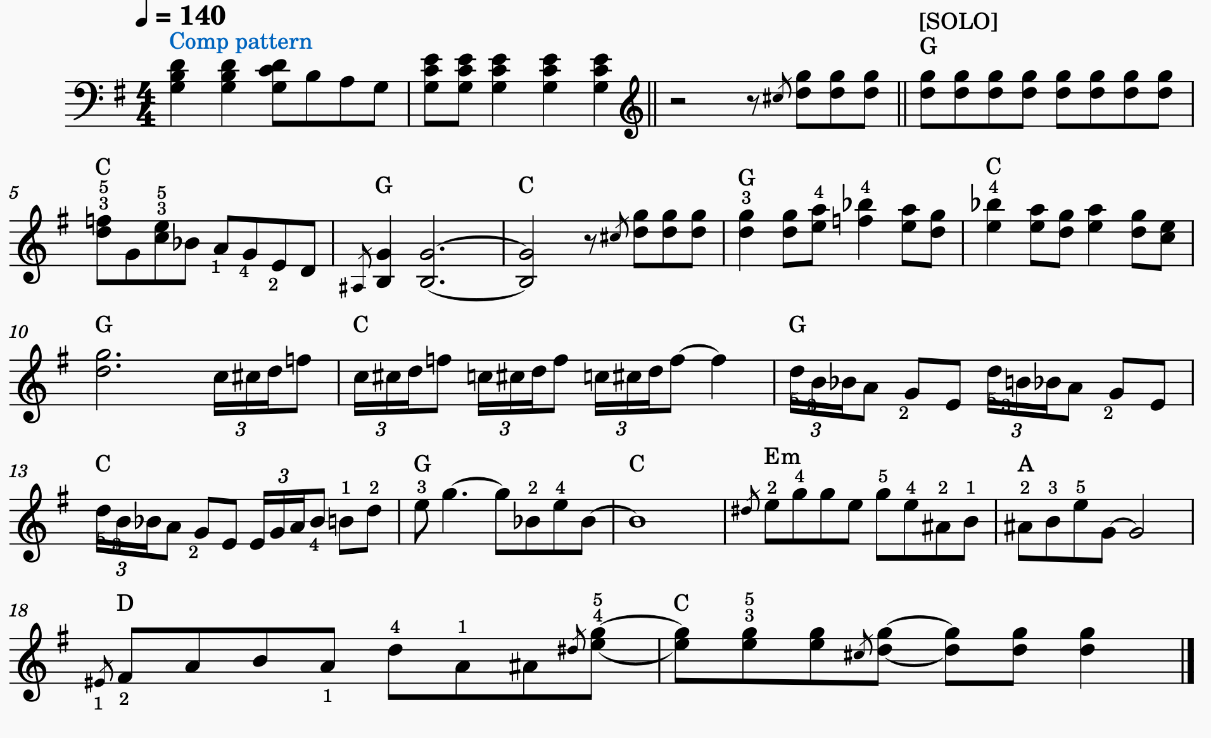
Ending: riff many times, hold a G, amen.
